1. Run IsItDown.exe

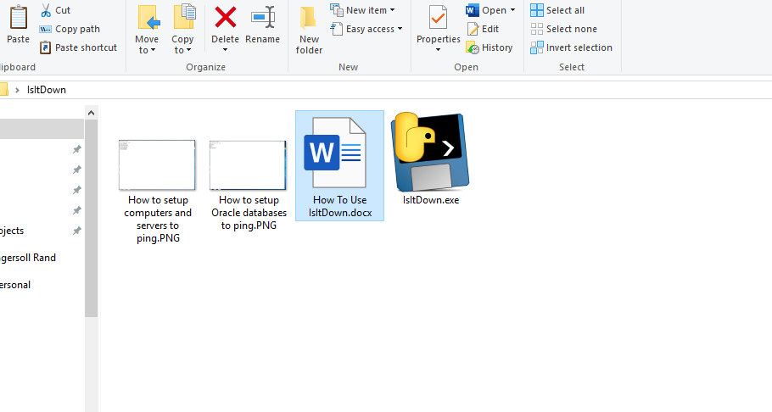

1. Command prompt will open, Type “Y” if you are pinging computers/servers or “N” if you are pinging Oracle databases and move to the next step.

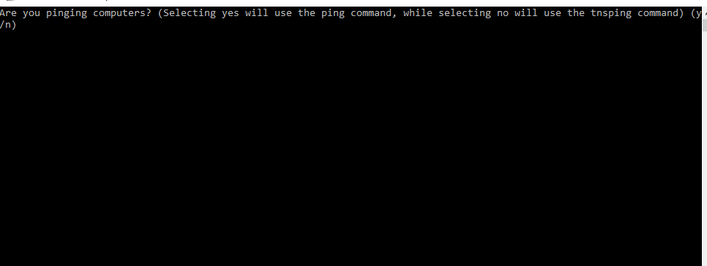

1. Next, it will prompt you to select which file to open

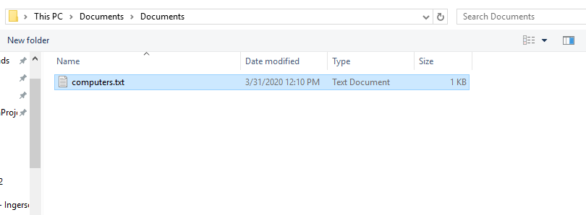

4. The command will automatically run after choosing your file and give you results when it’s finished on what was Reachable (Could be pinged) and Not Reachable (Could not be pinged). **It will also create a new text file on your desktop with the results (IsItDownResults.txt)**

*Running this 2-3 times will provide the most accurate results as it only pings twice instead of the standard 4 times to increase speed of testing.

